Chapter 14, Solution 50.

Determine what type of filter is in Fig. 14.87. Calculate the corner frequency f_{c}.

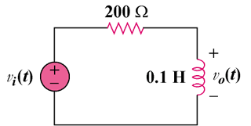

Figure 14.87
For Prob. 14.50.

Solution

and showing that this circuit is a highpass filter.

or

